ROLE PURPOSE: Knowledge Management Advisor
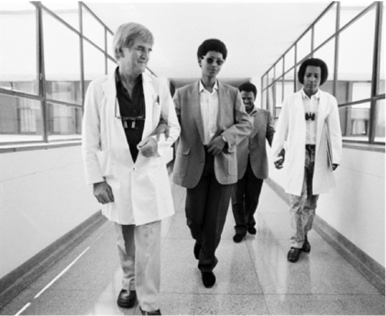  Image of Fred Hollows | How we value your contribution:
Remuneration package
We aim to provide an overall remuneration package that is attractive and fair. Our global remuneration framework ensures we align to local pay, employment conditions and laws, and we benchmark against the local market to ensure we offer competitive employment conditions that are appropriate to our sector.
Salary packaging
We qualify as a health promotion charity so the Australian Taxation Office (ATO) allows us to reimburse you for personal expenses without having to pay any income or fringe benefits tax that would normally be payable. These tax concessions are in addition to the income Tax Free Threshold.
Leave
You will have access to 20 days of paid annual leave each year (pro-rated for part-time employees) and receive 17.5% leave loading when you take annual leave. You will also receive 5 days paid leave between the Christmas and New Year period and other types of leave such as personal (sick or carers’) leave, paid parental leave, long service leave and compassionate leave. In addition, we provide culturally significant leave for employees with commitments under Indigenous and other cultural customs, traditional laws or religions.
Paid parental leave
We provide 14 weeks paid parental leave for primary carers at full pay and 4 weeks paid parental leave for non-primary carers, In addition, upon receipt of notification from the Family Assistance Office, primary carers may access 18 weeks paid parental leave at the statutory rate.
Performance & development
Our performance and development framework enables you to work closely with your manager to plan, manage, and review your performance throughout the year. This approach also enables you to discuss development opportunities and areas for growth.
Learning & development
Our approach to learning and development will enable you to have the information, skills and knowledge needed to do your job. We build the capacity of our people and support you with on-the-job experience, coaching and formal learning.
Leadership
Leadership is a key priority for us. We have customized leadership programs for leaders at all levels that are focused on supporting our people to be inspired, empowered and to make an impact in their work so that together we can achieve our vision.
Study support
We are proud that so many of our people are tertiary educated and we are committed to supporting tertiary education that is relevant to your work through our global study assistance program. Relevant applications for study support are considered annually, providing financial assistance and study days.
Recognition
Our recognition program has been designed to recognize and acknowledge our people who live our values of Integrity, Collaboration, Empowerment and Action, in everyday activities. We recognize our people in three ways: Peer-to-peer, manager recognition, as well as length of service.
Flexible work arrangement
You will have access to flexible work arrangements. We encourage a spirit of mutual flexibility, enabling discussions between you and your manager about maintaining work-life balance.
Health & safety
We are committed to supporting your health, safety and wellbeing. We have worker Health & Safety Representatives in each of our offices to assist in making your workplace safe.
Employee Assistance Program
You and your family will have access to free external, professional and confidential counselling assistance if you need help with personal, family or employment related matters.
Our Vision
We see a world in which no person is needlessly blind and Indigenous Australian’s exercise their right to good health.
Our Purpose
To end avoidable blindness and improve Indigenous Australian’s health.
At The Fred Hollows Foundation we offer a career where your talent and energy will help many see tomorrow.

 | To work in the Foundation you will: | Role purpose defines the broad accountabilities of the positions, which may change based on organisational need.  Please refer to divisional, team and individual work plans for more specific details
- Be eligible to work in Australia and other regions where you will be based
- Undergo background check including criminal records and qualifications check
- Undergo working with children check for positions which are identified as working with children.

ROLE PURPOSE
Role Title:  Knowledge Management Advisor |  | Division:  Knowledge and Innovation |  | Location:  Sydney or Melbourne | Date:  August 2018
Employment type:  Full time, Permanent |  | Reports to:  Global Lead – Development Effectiveness |  | Number of direct reports:  None | Leadership Band:  Leads a function

Purpose of the role:
The Knowledge Management Advisor will
Contribute to the following organisational outcomes:
- Staff across The Foundation have ready access to the best available information, resources and expertise to make evidence informed decisions and effectively manage The Foundation’s work
- The Foundation continuously strengthens its culture of learning, collaboration, and evidence informed practice, and improves upon its knowledge management products, systems, and processes
Manage the following organisational initiatives and outputs:
- Knowledge Management Strategy – The Knowledge Management Advisor will be responsible for finalising development of, effectively implementing, and monitoring and evaluating the organisation wide Knowledge Management Strategy
- Knowledge management quality improvement initiatives – The Knowledge Management Advisor will be responsible for identifying, planning and coordinating annually agreed knowledge management quality improvement initiatives.
- Knowledge products and processes – The Knowledge Management Advisor will be responsible for developing, maintaining and effectively engaging audiences with a set of organisational knowledge products and processes
- Knowledge curation – The Knowledge Management Advisor will support the organisations leadership stay informed about emerging issues and trends in eye health and development
- Other tasks as requested by your manager
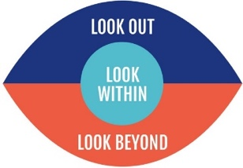  Our Capabilities:  - Look out  - Look within  - Look Beyond  As a member of the Foundation Family you will:  - Live by the values of The Foundation and support The Foundations culture, performance and brand.  - Adhere to all The Foundation policies & Procedures.  - Strengthen the health, safety and well-being of all/look out for the well-being.  - Lead, collaborate and contribute in all interactions. |  |  | Essential Experience:  - Strong experience designing and delivering knowledge management products, systems and processes. Must have demonstrated experience in several large complex organisations.  - Strong experience collaboratively developing of a range of knowledge products, from plain language case studies to technical reports  - Strong experience effectively gathering, assessing, synthesising, and presenting evidence from a range of information sources  - Strong experience facilitating learning forums  - Strong experience managing projects
Skills:  - Understanding of knowledge management principles and approaches  - Excellent written and oral communication skills  - Team player with positive attitude  - Creative problem solving and ability to work under tight deadlines  - Ability to understand and respond effectively to the needs of various audiences  - Ability to effectively support and collaborate with a diverse range of stakeholders  - Ability to translate complex information and data into clear and engaging publications and presentations |  |  | Desirable Experience:  - Strong experience in previous specialist knowledge management position/s  - Experience working in the international development and/or non-profit sector  - Working across cultures, and across languages.
Qualifications:  Relevant post-graduate degree | The position involves:  This position is recognised as having “Contact with Children” either direct or indirect
Travel:  Limited domestic and international | Additional Responsibility:  Ensure that the work for which they are responsible is carried out in ways, which safeguard the health and safety of workers.

