ROLE PURPOSE: Regional Operations Officer - SAME & Africa
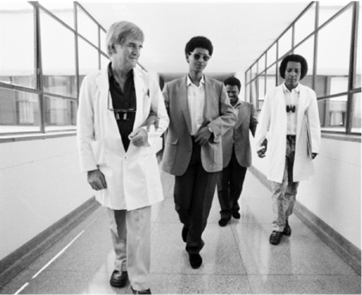  Image of Fred Hollows | How we value your contribution:
Remuneration package
We aim to provide an overall remuneration package that is attractive and fair. Our global remuneration framework ensures we align to local pay, employment conditions and laws, and we benchmark against the local market to ensure we offer competitive employment conditions that are appropriate to our sector.
Salary packaging
We qualify as a health promotion charity so the Australian Taxation Office (ATO) allows us to reimburse you for personal expenses without having to pay any income or fringe benefits tax that would normally be payable. These tax concessions are in addition to the income Tax Free Threshold.
Leave
You will have access to 20 days of paid annual leave each year (pro-rated for part-time employees) and receive 17.5% leave loading when you take annual leave. You will also receive 5 days paid leave between the Christmas and New Year period and other types of leave such as personal (sick or careers’) leave, paid parental leave, long service leave and compassionate leave. In addition, we provide culturally significant leave for employees with commitments under Indigenous and other cultural customs, traditional laws or religions.
Paid parental leave
We provide 8 weeks paid parental leave for primary careers at full pay and 4 weeks paid parental leave for non-primary careers, In addition, upon receipt of notification from the Family Assistance Office, primary careers may access 18 weeks paid parental leave at the statutory rate.
Performance & development
Our performance and development framework enables you to work closely with your manager to plan, manage, and review your performance throughout the year. This approach also enables you to discuss development opportunities and areas for growth.
Learning & development
Our approach to learning and development will enable you to have the information, skills and knowledge needed to do your job. We build the capacity of our people and support you with on-the-job experience, coaching and formal learning.
Leadership
Leadership is a key priority for us. We have customized leadership programs for leaders at all levels that are focused on supporting our people to be inspired, empowered and to make an impact in their work so that together we can achieve our vision.
Study support
We are proud that so many of our people are tertiary educated and we are committed to supporting tertiary education that is relevant to your work through our global study assistance program. Relevant applications for study support are considered annually, providing financial assistance and study days.
Recognition
Our recognition program has been designed to recognize and acknowledge our people who live our values of Integrity, Collaboration, Empowerment and Action, in everyday activities. We recognize our people in three ways: Peer-to-peer, manager recognition, as well as length of service.
Flexible work arrangement
You will have access to flexible work arrangements. We encourage a spirit of mutual flexibility, enabling discussions between you and your manager about maintaining work-life balance.
Health & safety
We are committed to supporting your health, safety and wellbeing. We have worker Health & Safety Representatives in each of our offices to assist in making your workplace safe.
Employee Assistance Program
You and your family will have access to free external, professional and confidential counselling assistance if you need help with personal, family or employment related matters.
Our Vision
We see a world in which no person is needlessly blind and Indigenous Australia’s exercise their right to good health.
Our Purpose
To end avoidable blindness and improve Indigenous Australian’s health.
At The Fred Hollows Foundation we offer a career where your talent and energy will help many see tomorrow.

 | To work in The Foundation you will: | Role purpose defines the broad accountabilities of the positions, which may change based on organisational need.  Please refer to divisional, team and individual work plans for more specific details
- Be eligible to work in Australia and other regions where you will be based
- Undergo background check including criminal records and qualifications check
- Undergo working with children check for positions which are identified as working with children.

ROLE PURPOSE
Role Title:  Regional Operations Officer | Division:  Programs |  |  | Location:  Sydney | Date:  January 2019
Employment type:  Full time, Fixed Term | Reports to:  Regional Operations Coordinator-SAME  Matrix reporting with Regional Operations Coordinator-Africa |  |  | Number of direct reports:  N/A | Leadership Band:  Leads Self

Purpose of the role:
The Regional Operations Officer is accountable for building the operational capacity of country teams within the SAME and Africa regions and accomplishing some key tasks related to program operations.

Key Responsibilities:

SAME Region
- Manage SAME regional Sharefile folder
- Prepare Annual Counter Terrorism Report & Quarterly Risk Management Report
- Coordinate and follow up HQ visitors (ToR, travel, trip reports etc)
- Provide regional programs info to different departments in Sydney/Melbourne based on their needs
- Where required, represent and attend the region to meetings in Sydney
- Provide logistic support for any events organized by region
- Provide secretarial support tor CoE working group
- Support the Regional Operations Coordinator to analyse PRISM outputs and system use against project implementation plans
- Prepare regional board reports & budgetary commentary
- Support and work with Regional Ops Coordinators for:
  - Capacity building of CO teams
  - Child Protection
  - Systems support
  - Procurement support & analysis
  - Maintaining compliance register
  - Safety and security
  - Setting annual outputs targets & review
- Other tasks as requested by the Regional Operations Coordinator, Associate Director – SAME, Global Lead – Programs Operations or Executive Team.

Africa Region
- Coordinate and follow up with HQ visitors to the region (ToR, travel, trip reports etc).
- Provide regional programs information to different departments in Sydney/Melbourne based on their needs
- Where required represent and attend to meetings in Sydney on behalf of Africa region team.
- Work closely with the regional based Regional Operations Officer and the Africa region team to provide surge capacity to the Africa country teams.

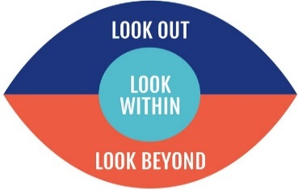  Our Capabilities:  - Look out  - Look within  - Look Beyond  As a member of the Foundation Family you will:  - Live by the values of The Foundation and support The Foundations culture, performance and brand.  - Adhere to all The Foundation policies & Procedures.  - Strengthen the health, safety and well-being of all/look out for the well-being.  - Lead, collaborate and contribute in all interactions. |  |  | Essential Experience:  - Proven experience in the development or humanitarian sector, preferably for an INGO working with headquarters and in-country teams.  - Demonstrated interest and knowledge of international development issues, public health and the donor landscape.  - Demonstrated knowledge of organisational strategies, systems, processes and standards.  - Knowledge of cultures within region and relevant countries.  Desirable Experience:  - Master’s Degree in Public Health, International Development or related field from reputable academic institution.
Skills:
- Outstanding organisational and time management skills.
- Strong computer skills and IT fluency specifically in purchasing and project management systems and Microsoft Office suite applications.
- Strong communication skills including fluency in written and spoken English and the ability to write effectively for varied purposes and audiences.
- Ability to support the development of skills and capacity
- Demonstrated financial management skills
- Good problem-solving skills: demonstrates resilience and initiative when faced with challenges.
- Strong interpersonal, facilitation and presentation skills.
- Demonstrated capacity to work effectively in cross cultural / mixed language environments.
- Ability to meet conflicting deadlines.
- An energetic self-starter with the resilience, pace, interpersonal flexibility and comfort with ambiguity to succeed within the evolving and sometimes demanding culture.
- Ability to be flexible in the face of changing priorities and maintain a sense of humor.

Qualifications:  Bachelor Degree in Public Health, International Development or related field. |  | The position involves:  This position is recognised as having “Contact with Children” either direct or indirect
Travel:  International/Domestic |  | Additional Responsibility:  N/A

